

E-PROJECT!

***Bookly.***

Group Members:

* ***Saad Jawed. Student1413935.***
* ***Saad Rizwan. Student1414011.***
* ***Avais Khalid. Student1370095.***

Submitted to:

*Miss* **Ayesha Arif.**

Table of content

Acknowledgement .......................................................................... 2

Introduction .................................................................................... 4

Problem statement.......................................................................... 5

**Executive summary.......................................................................... 5**

Colors and branding........................................................................ 6

Group work...................................................................................... 7

Website Model Screenshot............................................................... 8

Coding screen shot........................................................................... 11

Conclusion ...................................................................................... 13

Acknowledgment:

This web application project is the undertaken as a mandatory requirement for the course of **Back-End** development based on

" **Php, MySql** " in Aptech learning institute. The aim of this project to design a professional product or service selling website. We have taken great efforts in this project. However, it would not have been possible without the kind support and help of our facilitator

**Miss Ayesha Arif**. We would like to extend our sincere thanks to her.

Introduction:

The project report has been prepared based on website we created. The real-life situation can be different what we learn so it is best opportunity for us to analyze our self while making professional website. Our topic Books selling in stores. In this project we created website to highlight our products and availability on internet. Our main focus to update products and prices on daily basis. Website is necessary in every good business. In other words, web help to view an online business address, products and others. This is where our customers and new client’s associates go to find us on the Internet. A website is a great way to share our story; we can tell our audience why we started this business, our goals and how it will help to people. Website helps to create strong bonding with clients and also can get more new clients. Our website based on 5 pages which we will discuss further in upcoming pages. Our web theme mainly bases on white, Purple and black colors. Purple color we used because it represents loyalty. White and black give some elegant and clean look.

Problem statement:

It is real concern in modern era that if you don't have online availability but your competitors getting advantage of it. In this dynamic world you can lose your position in market. **Books.** are expensive to buy online so our main focus to be, display our products and competitive prices online. Our main problem to attract customers with updated discounted prices & offers. Also, customers can easily excess to us with just clicks away.

Executive Summary:

Across Pakistan the businesses are getting towards to E business has seen an explosion of growth over the last few years. Our main competitors our **Liberty Books.** have good excess on internet and social pages. They connected and updated prices of products. Our main focus to compete with them and for this we have to update our prices and products on daily basis.

Colors and branding:

The colors we choose Purple, white and black. The Purple color shows towards loyalty. We want our customers to be loyal with our price strategy and will always rely on our prices. White background and black text over gave some clean and elegant look to our website. Our logo also based on these colors.

**Colors codes:**

C:\Users\Ahsan\Desktop\blue.png Purple: #8e44ad.

C:\Users\Ahsan\Desktop\black.png Black: #333.

C:\Users\Ahsan\Desktop\white copy.png White: #FFF.

**Logo:**

***Bookly.***

|  |  |  |  |  |
| --- | --- | --- | --- | --- |
| **No** | **Task** | **Actual Start**  **Date** | **Actual**  **Days** | **Team Members** |
| 1 | Analysis &  Designing | 5-August-2023 | 3 | All Members |
| 2 | Development  Home page | 10-August-2023 | 3 | All Members |
| 3 | Further pages  Development | 15-August-2023 | 5 | All Members |
| 4 | Testing | 19-August-2023 | 2 | Saad Jawed  Saad Rizwan |
| 5 | Documentation | 19-August-2023 | 1 | Saad Jawed  . |

Web model

1) Home page:

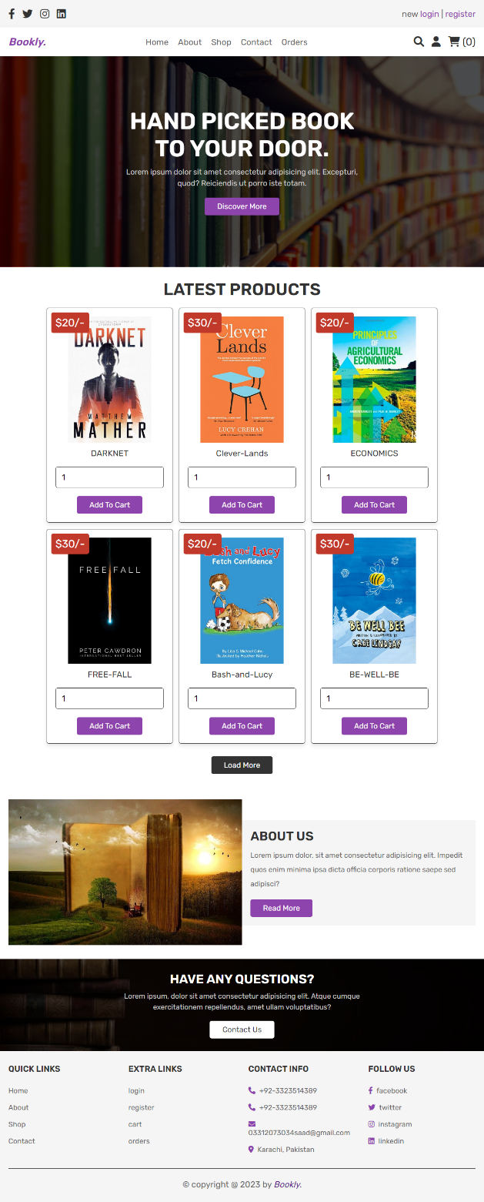

2) About Us:

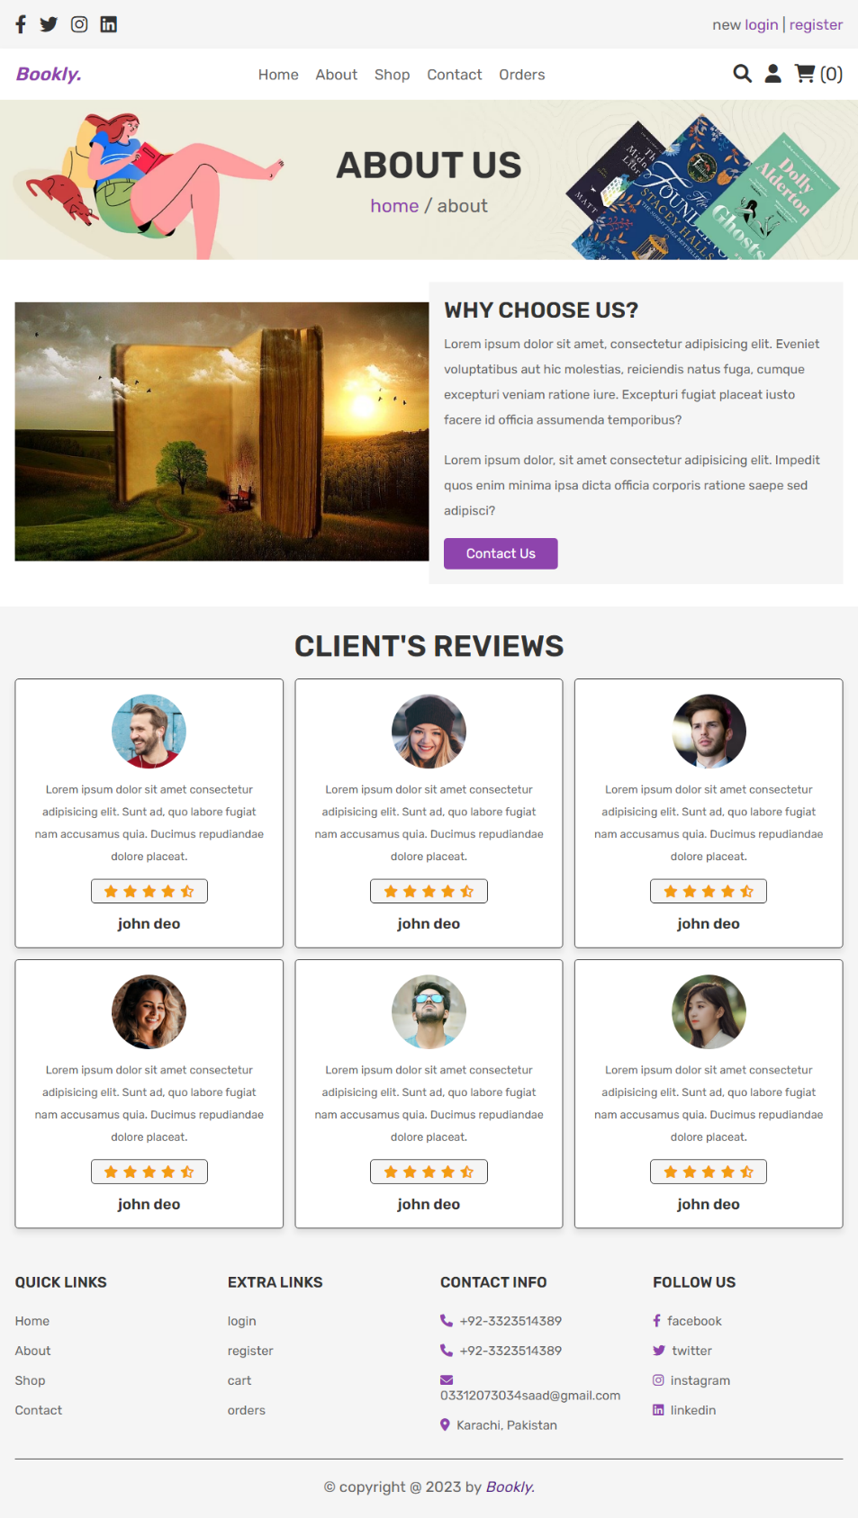

3) Shop

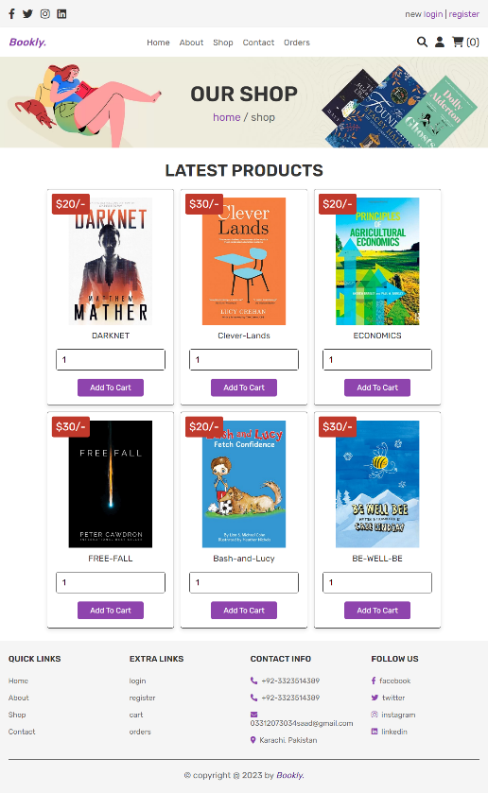

4) Contact us:

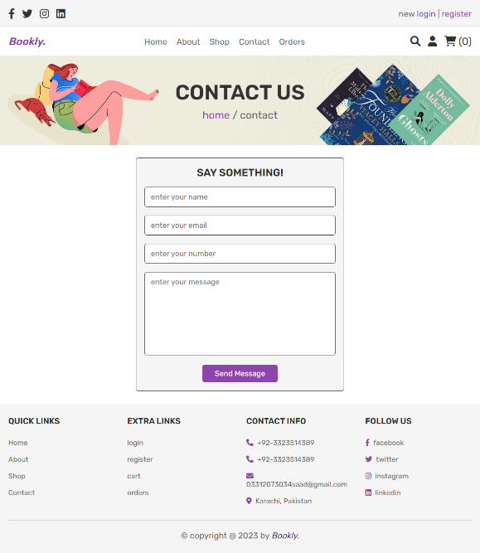

5) Orders:

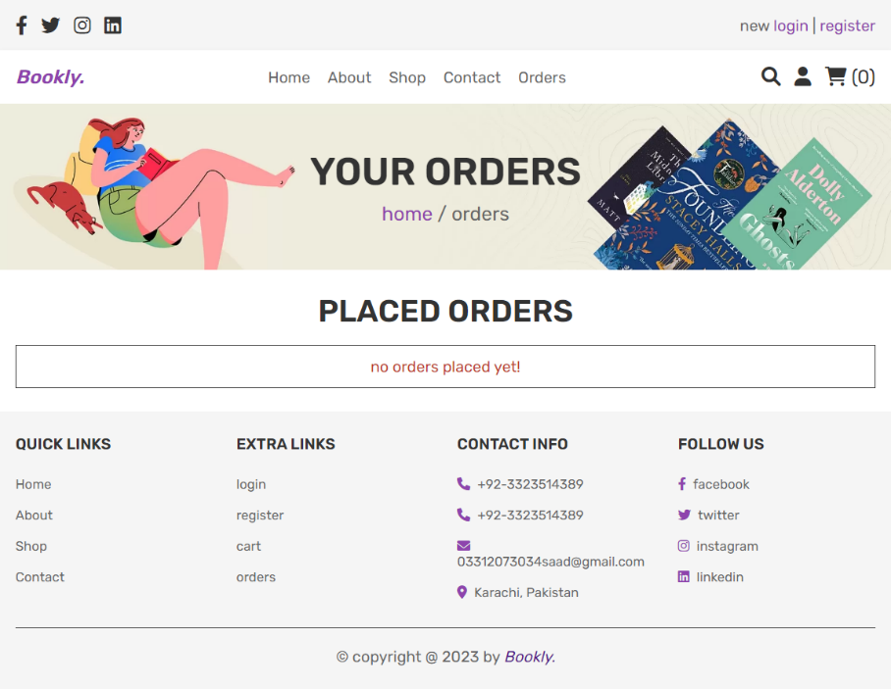

5) Cart:

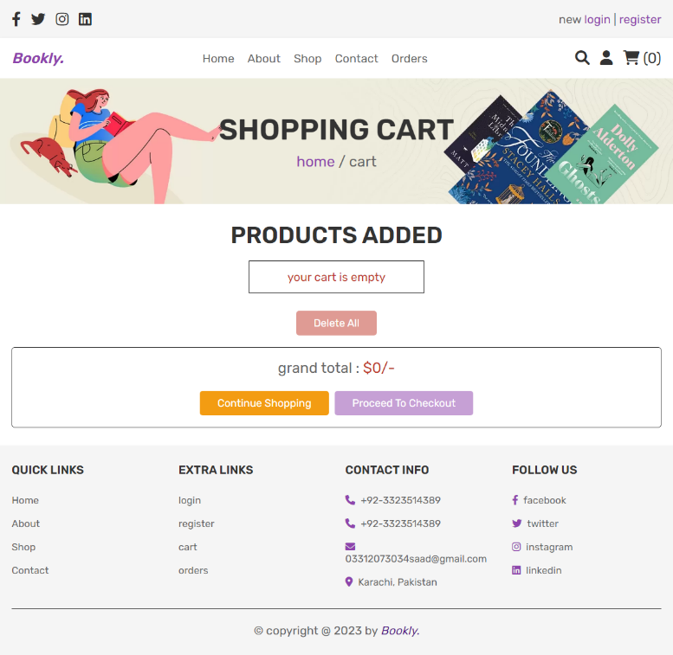

**Conclusion:**

This project primarily base on the Books Selling store website. The website took some hard efforts in design process, we sort out issues with mutual discussions in group and with the help of kind teacher, who facilitate us to complete the project. Our main aim to target the market with our low-price strategy. We need to update discounted price on daily basis to attract the potential customers and also can add or remove the products any time. The web model easy to understand and not a burdensome for visitors. They can contact us, easy excess to social pages and also can see our address and other info easily.